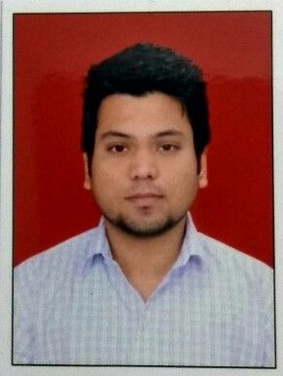
VISHESH PANDEY

FARIDABAD, HARYANA-INDIA
Contact no: +91- 9818952073
E-mail: visheshpandey0@gmail.com

CAREER OBJECTIVE

- Java Developer with strong Core Java, J2EE, Struts 2, Hibernate, JQuery & CSS experience
- Hands on Experience in SQL and MySQL
- Ability to work in the given timeline, excellent interpersonal, organizational and time management skills
- Ability to work on multiple projects simultaneously
- Contribute in all phases & Design and develop high-volume life cycle
- Delivering performance write well designed, testable & efficient code
- Should be able to work independently as well as part of a team

ACADEMIC ACCOMPLISHMENTS

Institute | Degree | CGPA/ % | Year
B.S Anangpuria Educational Institutes | Bachelor of Technology (Computer Science & Eng.) | 71% | 2016
Kendriya Vidyalaya No.2 Faridabad(HR) | Senior Secondary | 61% | 2012
Kendriya Vidyalaya No.1 Faridabad(HR) | Secondary | 65% | 2010

PROFESSIONAL SUMMARY

- OOPS concepts & design / integration patterns, Multithreaded programming, Generics and JVM
- Database query, indexing, optimization, normalization and de-normalization concepts
- Sound knowledge of modern software architecture and development techniques

CERTIFICATIONS

- Completed certification course in PHP and MySQL conducted by IIT Mumbai in 2015
- Completed certification course in Core/Advance Java from DUCAT in 2015
HOBBIES

- Title : WEB TUBE
- Application Tools : Apache Tomcat-7 , JDK-7, Eclipse Luna
- Role Played : Developer and Tester
Description

- WEB TUBE a dynamic video sharing web application basically designed for entertainment and educational purpose, the main objective of this application is to watch and upload videos securely.
- Then user could easily use it for any purpose like education, sports, music, short original videos. The following modules will help users to share and watch videos. This project or web application is aimed for providing the users to watch videos for their different purpose. When the users first visit the application, he/she will go to registration page. After registration, they will go to home page.

- Then user could avail the services provided by this project. After registration the user can upload, watch the video and make comments and like/dislike on the video. Also there will be an admin panel for administrator login.

- Title : Artificial Neural Network Based Signature Recognition & Verification
- Application Tools : Apache Tomcat-7 , JDK-7, Eclipse Luna
- Role Played : Studying over 2 month & Developing verification signature (individually)
Description

- The human signature is proven to be the most important for access. Signature of the person is proven to be the important biometric attribute of a human being which can be used to authenticate human identity

- There are many biometric characteristics by which one can have own identity like face recognition, fingerprint detection, iris inspection and retina scanning.

- Voice reorganization and signature verification are the upcoming technologies for the human identity. Human signature can be handling as the image and can be recognized by using the computer vision and neural network. With the help of the modern technology there is possibility to develop such algorithm with help of which one can able to recognize and verify the human signature.

PERSONAL DETAILS

- Date of Birth : 17.03. 1995
- Marital Status : Unmarried
- Language : English/Hindi
- Father’s Name : Uma Shanker Pandey
- Address : P1/25-A,SRS Pearl Floor,SRS City ,Sector-87 ,Greater Faridabad(HR)

HOBBIES

- Sketching
- Developing & Designing web pages

I hereby declare that all the information given above is correct as per my knowledge.
Signature
VISHESH PANDEY

